**GOVERNMENT ARTS COLLEGE FOR**

**WOMEN,SALEM-8.**



**DEPARTMENT OF COMPUTER SCIENCE**

**Optimizing flight booking decisions through machine learning price predictions**



**PROJECT REPORT TEMPLATE**

1 INTRODUCTION

* 1. **Overview**

**In this article ,we wil be analyzing the flight fare prediction using Machine Learning dataset using essential exploratory data analysis techniques then will draw some predictions about the price of the flight based on the some features such as what type of airline it is,what is the arrival time,what is the departure time,what is the duration of the flight,source,destination and more.**

* 1. **Purpose**

**This project is used for flight ticket booking.People who work frequently travel through flight will have better knowledge on best discount and right time to buy ticket. For the business purpose many airline companies change prices according to the season or time duration.They will increase the price when people travel more.Estimating the highest prices of the airlines data for the route is collected with features such as Duration,Arrival and Departure.**

**2 PROBLEM DEFINITION & DESIGN THINKING**

**2.1 Empathy Map**



**2.2 Ideation and Brainstorming Map**



**3 RESULT**

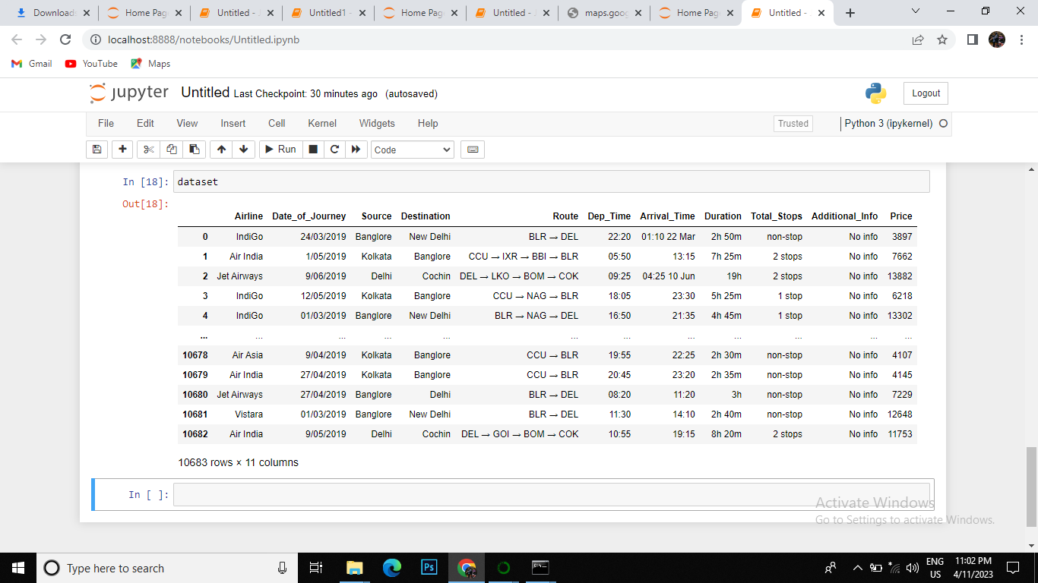

**4 ADVANTAGE AND DISADVANTAGE**

**Advantage**

* **Traveler get the fare prediction handy using which it’s easy to decide the airlines.**
* **Saves time in searching / deciding for airlines.**

**Disadvantage**

* **Improper data will result in incorrect fare predictions.**

**5 APPLICATION**

**A flight price prediction which predicts fares of flight for a particular data based on various parameters like source,Destination,Stops & Airlines.**

**6 CONCLUSION**

**Machine Learning algorithms are applied on the dataset to predict the dynamic fare of flights.This gives the predicted values of flight fare to get a flight ticket at minimum cost.The values of R-squared obtained from the algorithm give the accuracy of the model.In the future,if more data could be accessed such as the current availability of seats,the predirect results will be more accurate.Finally, we conclude that this methodology is not preferred for performing this project.We can add more methods, more data for more accurate results.**

**7 FUTURE SCOPE**

**More routes can be added and the same analysis can be expened to major airports and travel routes in india.The analysis can be done by increasing the data points and increasing the historical data used.That will train the model better giving better acurates and more savings.**

**8 APPENDIX**

1. **Source code**

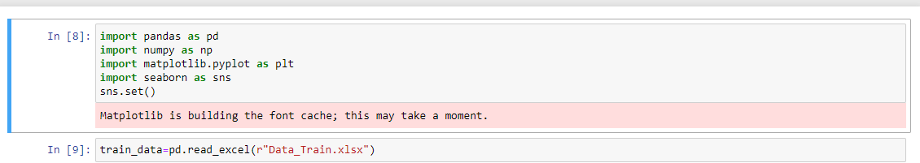

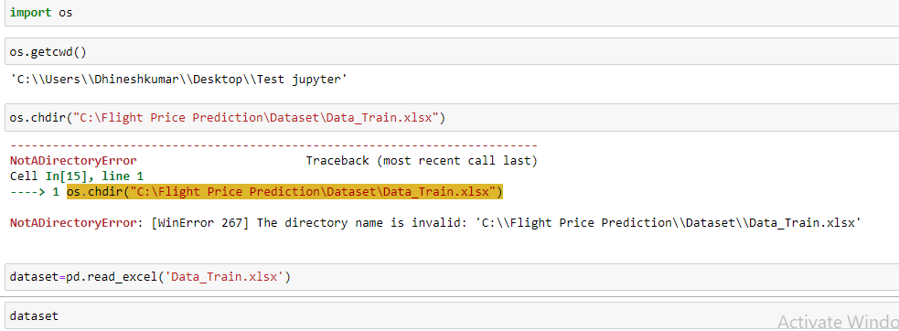

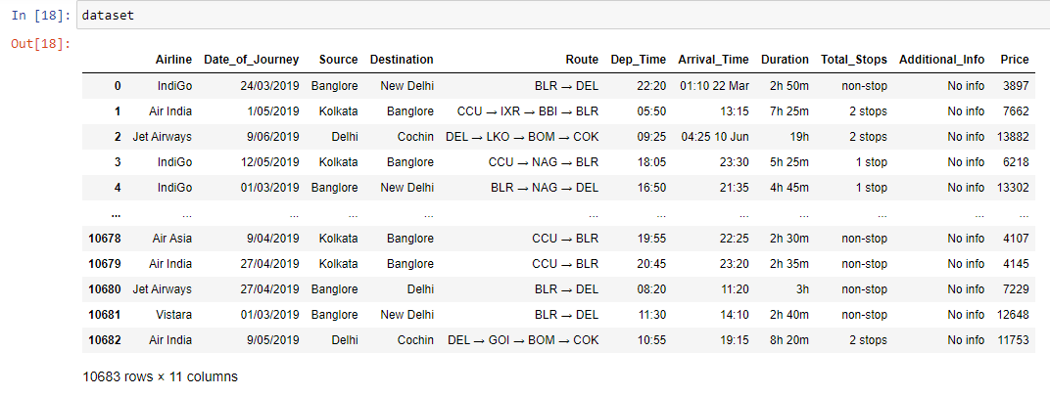

Presented by

SHALINI.V(Team Leader)

SHANMUGAPRIYA.B

SASIKALA .R

SENBAGAPRIYA.T